I. Social Problems

A. Study of social problems

1. Identifying social problems?

2. Discovering the causes?

3. Discussing possible solutions?

B. Identifying Social Problems and the “problem” of point of view

1. Social problems from the pt of view of corporations and the wealthy

a. “big” government

i. over-regulation

ii. public ownership

iii. taxation

b. solutions

i. deregulation

ii. lower taxes

iii. privatization

iv. tort reform

v. subsidies; “bailouts”

vi. expand rights as persons

“free” speech”

participation in political process

2. Identifying Social Problems and Corporate Media

a. violent crime: “If it bleeds, it leads”!

b. disease: SARS, West Nile Virus, “the Flu,”
Swine flu, EBOLA

c. disasters

i. natural

ii. Malaysian Airlines Flight MH370

iii. global economic crisis: OOOps but all over “Recovery”: GNP^, Corp profits^, Dow Jones^

d. how real are media social problems?

i. violent crime

ii. disease

iii. disasters

e. Consequences

i.Annenberg study

ii. mass distraction and stupification

C. Our Starting Point: VITAL NEEDS

1. Vital needs to enjoy a decent life

a. Good job

i. decent wages

ii. reasonable hours

iii. security in job

iv. benefits

v. vacation/leisure time

b. housing

i. affordable

ii. quality

c. food security

d. education

e. environment

i. clean air

ii. clean water

f. health care

g. security of person and family

h. physical infrastructure

- voice in political system

2. Social problem from this perspective: when millions do not have their vital needs met

3. Vital needs as social problems

- Jobs

i. types of jobs

ii. unemployment, underemployment

are available; it’s that employers do not have enough work to be done to need to hire more workers.
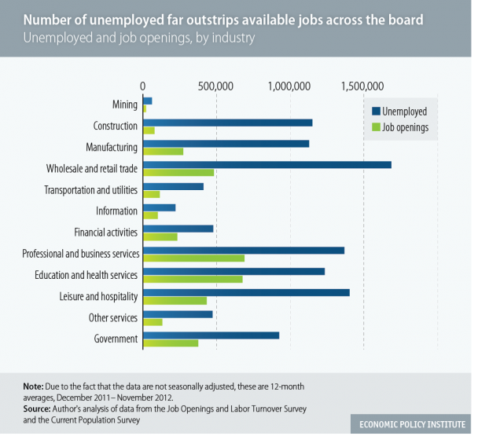

iii. real income

iv. middle class jobs: increased hours

v. decline in benefits

30% companies cut or increased cost

stipend vs health care?

vi. decline in leisure time

b. housing

i. 1 out 10 families

ii. affordability

iii. homelessness

2 to 3.5 million per year

35% families, 13% veterans

c. hunger

i. food insecurity

1 in 6 families food insecure

49 million/17 million children

4.8 million households used private food pantries

ii. since 2008: +50% food stamps

d. education

i. higher education: cost^ student debt ^

ii. K-12: overcrowding, unsafe, inadequate funding

iii. privatization

e. environment

i. air and water quality

ii. chemical pollution

f. health care

i. health care system

most costly

bankruptcies

millions uninsured

ii. Obamacare

who wrote it?

where implemented first?

“wealthfare”

“covered”!!

g security of person

- criminal justice-industrial complex

2.3 million

25% of world’s incarceration population

ii. military-industrial-intelligence complex

$1 trillion

NSA

h. physical infrastructure

i. sewage systems

ii. bridges

iii. roads

iv. electrical grids

v. railway

vi. informational networks

j. voice in political system

i. who runs?

ii. who finances?

II. Why are the vital needs for millions threatened?

- Who Rules America?

Citigroup’s Equity Strategy
“Revisiting Plutonomy: The Rich Get Richer”

“These economies (U.S, UK, Canada and Australia) have seen the rich take an increasing share of income and wealth over the last 20 years, to the extent that the rich now dominate income, wealth and spending in these countries . . . favorable treatment by market friendly governments have allowed the rich to prosper and become a greater share of the economy in the plutonomy countries . . .[much of this increase] at the expense of labor.”

Warren Buffet, multibillionaire:

“There is a class war in America and my class is winning.”

- Upper upper class and large multinational corporations

2. U.S. is a plutocracy or corporatism

- achieve goals despite resistance

b. achieve goals at expense of us (vital needs)

c. shape and control institutions

economy

political system

media

3. our vital needs are:

i.cost to rich and corporations

ii. source of profit

- Corporations

1.“persons”

2.legal obligation

From The Corporation:

http://www.youtube.com/watch?v=Pin8fbdGV9Y&list=PLB3A3B6087444D958
http://www.youtube.com/watch?v=8SuUzmqBewg&list=PLB3A3B6087444D958

Enron

http://www.thedailyshow.com/watch/mon-june-7-2004/tape-worms

